Кропачова О. П.
READING 6 Form
My family and me

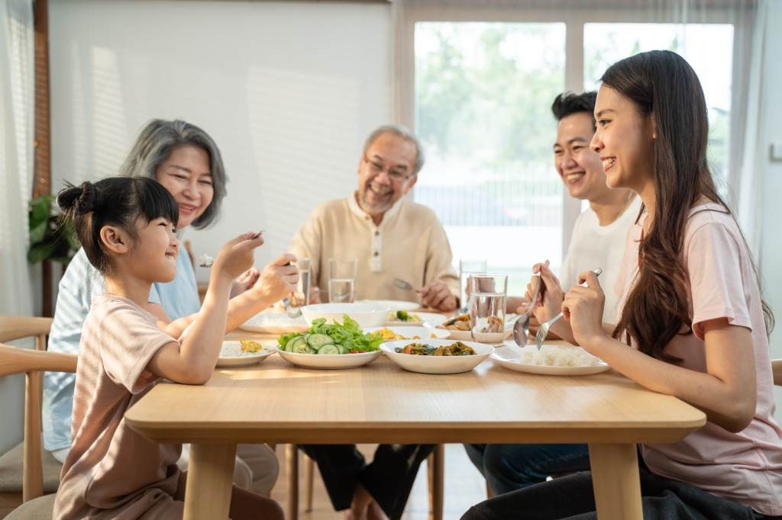We are five people in our family. I have one brother and one sister of mine with my parents. My mother is a housewife, working at home. She was a school teacher, but because of taking care of us she left the job. My father is a doctor.
My sister is studying in the medical college; my brother is studying English literature at a local college. I am the youngest member of our family. We are a great family, living together. We love each other a lot. We make so many fun things together.
My father takes us to a family picnic often. We really enjoy that. My parents are really kind and interesting. Their behavior with other people is really impressive. They love to help people. They are having a good relationship with people.
Read the text and answer the questions below:
1 How many people in the family?
a seven b five c four d six

2 What is the profession of the father?
a nurse b teacher c doctor d engineer

3 What does the mother do for work?
a doctor b housewife c nurse d teacher

4 What is the sister studying?
a Mathematics b History c Medicine d English literature

5 What is the brother studying at college?
a Medicine b Biology c Chemistry d English literature
6 Who is the youngest member of the family?
a the brother b the narrator c the sister d the father

7 What activity does the father often take the family to do together?
a visit relatives b attend church c go on picnics d go shopping

8 What trait do the parents exhibit towards people?
a fear b anger c indifference d kindness

9 How did the mother contribute to the family before becoming a housewife?
a she was a lawyer b she was a teacher c she was a nurse d she was a doctor

10 What do parents love to do?
a to help people b to give presents c to invite guests d to rest at home

11 What quality do the parents have as to their behavior with others?
a boring b rude c impressive d shy

Answers:
1 | 2 | 3 | 4 | 5 | 6 | 7 | 8 | 9 | 10 | 11

Keys: 1b 2c 3b 4c 5d 6b 7c 8d 9b 10a 11c

Listening. “My hobbies” Teacher`s Paper
Tapescript
Hobby is what a person likes to do in his spare time. Different people like doing different things, so we can say that people have different hobbies. “Tastes differ,” says the proverb.
Usually people choose hobbies according to their interests. Some people are fond of collecting different things. They collect coins, postcards, toys, objects of art and stamps. I have a friend Vika. Collecting coins is her hobby.
My favorite occupation is reading. I like to read story books, detectives, historical books and any kind of material that I find interesting. I like to read because my grandmother always read me some fairy tales and stories during my childhood. When I was 10 my parents always bought me books to read. They always told me that habit of reading is one of the best traits that a man can boast. Now I read about anything that is available. Reading enables me to learn about so many new things. I learn about some historical facts, different human achievements, space travels and other fascinating things of our world. My room is full of different books and I dream of becoming a writer.
My younger brother, on the opposite, is not hopping to make his computer hobby his future profession. He just plays computer games and doesn’t see any sense in combining career with hobby. It simply became his favourite activity in his leisure time and is helping him to relax. I respect his choice. But anyway it is great, when your hobby is your profession.
Answer Keys
Part 1 1T 2F 3F 4T 5F 6T
Part 2
1 Reading
2 Coins
3 The author enjoys reading because they learned to love it from their grandmother and parents. They also find it a great way to learn about the world.
4 The author's brother does not want to combine his hobby of playing computer games with his career.
5 No, the author respects their brother's choice not to pursue a career related to their hobby. They believe that it is okay to have a hobby simply for enjoyment.
6 The text discusses the concept of hobbies, how people choose them, and the different ways hobbies can impact their lives. It highlights the importance of having hobbies and the diversity of interests among people.

Pupil`s Answer Paper _______________________________
(Name Surname Form)
Part 1. True or False
- Hobbies are activities people enjoy in their free time.
- Everyone has the same hobbies.
- Hobbies are always chosen based on a person's career goals.
- The author's hobby is reading.
- The author's brother wants to make his computer hobby his career.
- The author believes that combining hobby and profession is always the best option.
1 | 2 | 3 | 4 | 5 | 6

Part 2. Answer the questions
1. What is the author's favourite hobby?
____________________________________________________________________________________
2. What kind of things does the author's friend Vika collect?
__________________________________________________________________
3. Why does the author enjoy reading?
__________________________________________________________________
4. How does the author's brother feel about combining his hobby with his career?
__________________________________________________________________
5. Does the author believe that everyone should turn their hobby into a profession?
__________________________________________________________________
6. What is the main idea of the text?
_____________________________________________________________________________________

