Topic of the lesson: Breakfast in Vietnam
Aims of the lesson: to listen to the story and do tasks to it, read words and sentences, get acquainted with the food traditions of Vietnam;to develop the expressiveness of reading in English, logical thinking, language guessing, memory and attention of students, pragmatic and health-preserving competence of schoolchildren; to make students want to lead a healthy lifestyle and proper nutrition;
Type of the lesson: Application of skills and abilities
Materials: Activity Book; presentation; audio "Breakfast in my country"; PE minute video; interactive game "Food"; song " the Noodles"; an A4 sheet with an individual task, colored pencils and felt-tip pens for everyone
Сourse of the lesson
1. Organisation of the class
1.1. Greeting and introduction
-Hello, guys! My name is Nadiia Vasylivna and today we will work together
at the English lesson.
1.2.Mood scale
-There is a question «How are you?» and many smiles on the slide. You have to answer the question using a smile that matches your mood. You start your answer with «I am».
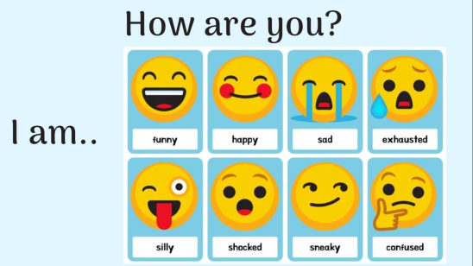
2.Warm-up
- Now let’s remember words from the topic «Food». You can see the pictures on the screen. You have to listen to the word and connect it with the picture.
Answers:
1 picture is a pizza
2 picture is a juice
3 picture is a soup
4 picture is a ice cream
5 picture is a salad
6 picture is a noodles
2.1. Recalling the use of phrases «I like ….», «I don`t like…»
Now share your favourite and not favourite food using phrases «I like ….» and «I don`t like…»
3. Presenting the topic, aims of the lesson and motivating students
The topic of our lesson is «Breakfast in Vietnam ». You and I will listen to and read the text and do interesting exercises on it
4. Reading Comprehension
4.1. Pre-reading activity
- Open your student books at page 105, look at the pictures in exercise 6, name the food you can see.
-What food can you see? (mango, mango juice, soup, greencry)
-Do you like mangoes?
-Do you like soup?
4.2. Listening to audio material
-Your assumptions - What can this text be about?
-Let's listen to the audio and also follow the text in the student book
- Name the fruits you heard in the audio (mango, orange, apple, coconut)
- Where Duong is from? (Vietnam)
4.3. Reading and translation of the text
-Now let's read it in chain one sentence at a time and translate it.
-What is Duong's favorite breakfast? (Pho)
-What is pho? (soup)
- What is Duong's favorite juice? (coconut juice)
4.4 Read and write the missing word
-Now, on the sheets that I am giving you, you have to write the missing word in the sentence
-For example, the first sentence. Duong favourite breakfast is ...
-What word is missing here? (Pho)
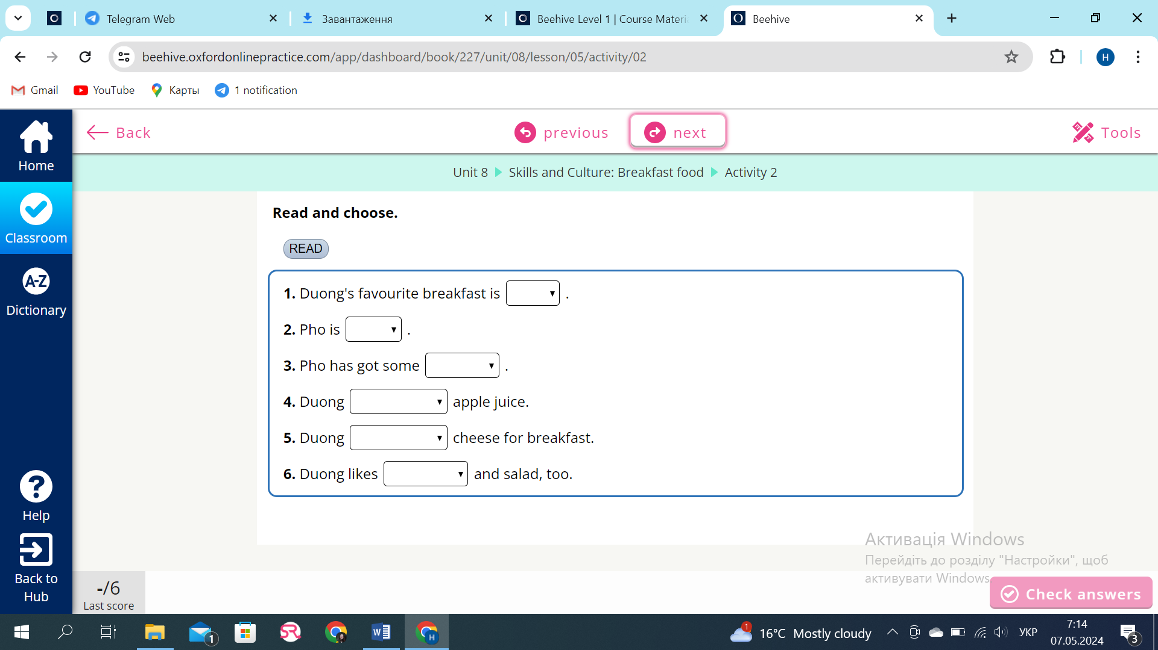
-Let's check this task. Read the completed sentences
P1: Pho is soup.
P2: Pho has got some noodles.
P3: Duong doesn`t like apple juice.
P4: Duong doesn’t like cheese for breakfast.
P5: Duong likes eggs and salad, too.
Well done.
Physical activity
Now let's get some rest. We're going to do a physical activity. Please stand up.
https://youtu.be/dUXk8Nc5qQ8?feature=shared
4.5. True / False
-Now let's check how attentive you were. You have to read the sentences in exercise 7 and say whether the sentences are true or false
-Look at the first sentence : Duong likes soup is a true statement.
-Who wants to read the second statement?
2)Duong has got some coconut juice. It is true or false? (false)
-Who wants to read the third statement?
3) Duong likes apple juice and cheese (false)
-Who wants to read the fourth statement?
4) Duong's favorite breakfast is bread and eggs (true)
Let's check number 1 true or false? (true)
Let's check number 2 true or false? (false)
Let's check number 3 true or false? (false)
Let's check number 4 true or false? (true)
5.Writing
5.1. Exercise 8 on p.105
Look at exercise 8 on p.105
Don't it is a short form for do not. That is, if we say I don't like apple juice, we match with I do not like apple juice
- Who will read the second sentence and match it with the full form?
2)I don’t like olives – I do not like olives.
- Who will read the third sentence and match it with the full form?
3) I don’t - I do not
- Who will read the fourth sentence and match it with the full form?
4) No, I don’t – No, I do not
5.2.Work with cards
Each of you got an individual card. You have to complete the sentences, changing do not to don't.

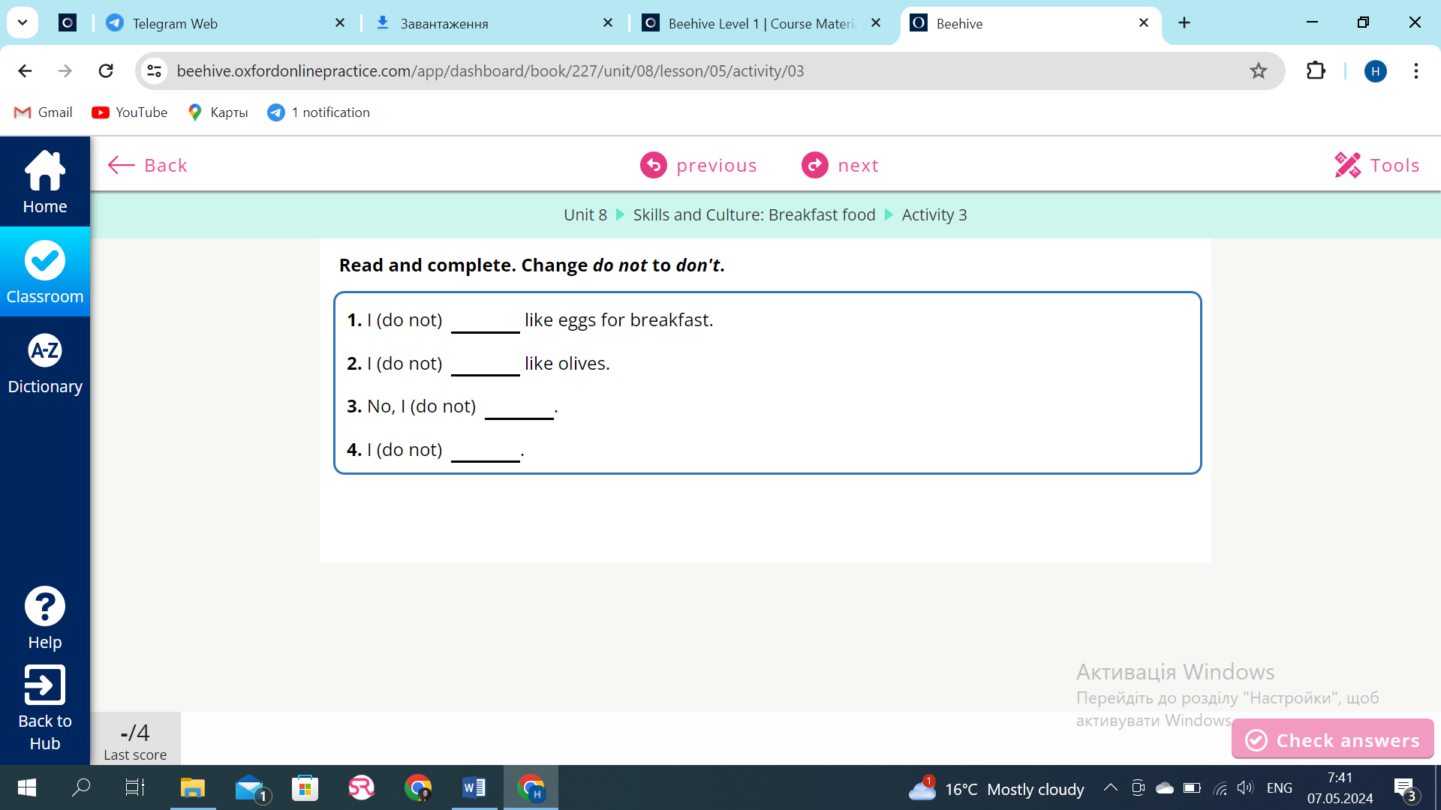
Let’s check this task. Read the sentences
P1: I don’t like eggs for breakfast.
P2: I don’t like olives.
P3: No, I don’t.
P4: I don’t.
6. Creative task. Breakfast in my country. (to spare time)
- Now you have to write about your favorite breakfast on the sheet that I gave you. You can see a sample on the board. You can also draw your breakfast
- When you are ready to answer, raise your hand.
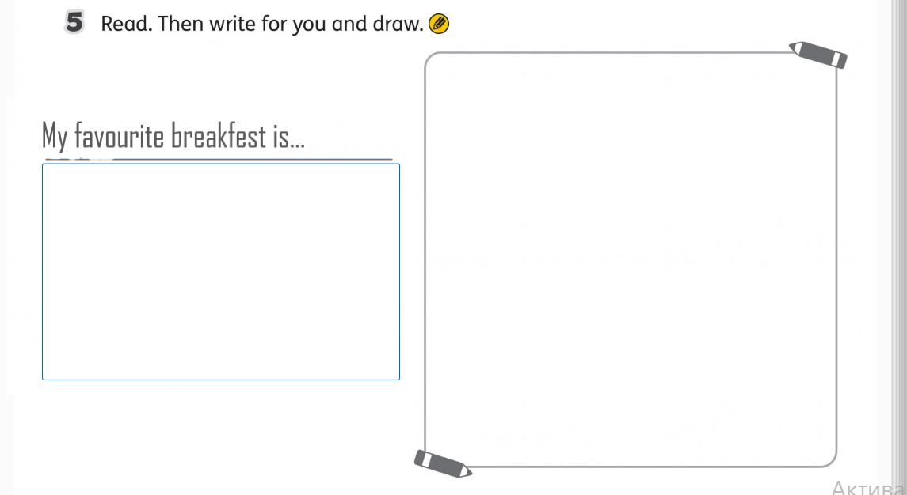
7.Summary of the lesson
7.1. Reflection
-Did you like today’s lesson?
-Choose an emoji emotion that matches your mood at the end of the lesson.
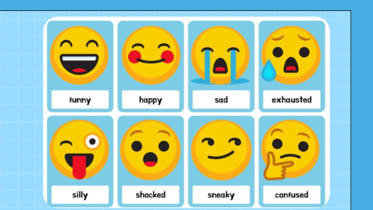
7.2. Verbal assessment of class work
-I am glad that you liked tha lesson was a pleasure to work with you.
-You guys are great! You coped with all the tasks. And you also did a good job in class, I liked your activity and work in class.
7.3 Sing a song
And now we sing a little
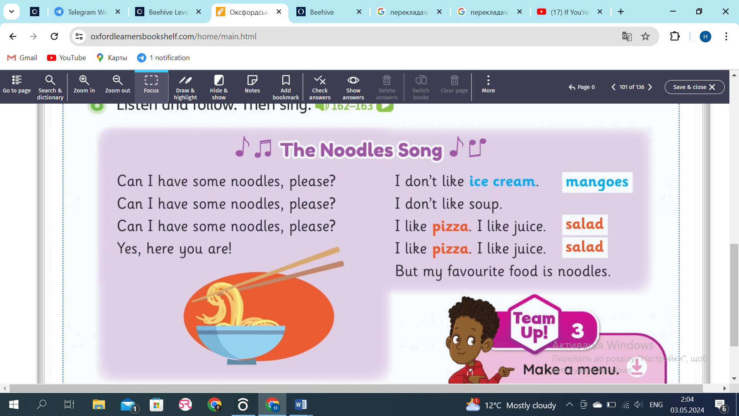
The lesson is over. Goodbye!

