Match the words with the items

- Dress 7. Boots
- Mittens 8. T-shirt
- Coat 9. Skirt
- Sweater 10. Shoes
- Jeans 11. Hat
- Scarf 12. Shorts
a. 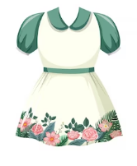 b. 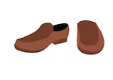 c. 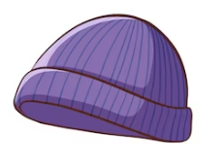 d. 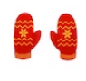 e. 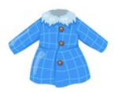 f. 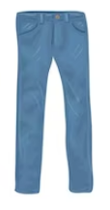
g. 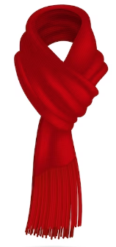 h. 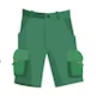 i.  j. 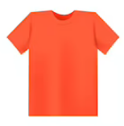 k. 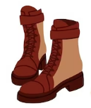 l. 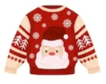

Complete the sentences

a scarf round your waist
gloves/mittens round your neck
You can wear a belt on your feet
a tie on your hands
a hat/ a cap on your head
socks/ boots/shoes

