Task 1. Chose the correct word or sentences to the pictures
1. 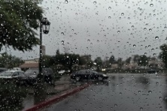а) Stormy б) Windy в) Hot г) Rainy
2.  а) Cloudy б) Windy в) Sunny г) Stormy
3.  а) Stormy б) Sunny в) Windy г) Rainy
4.  а) Rainy б) Foggy в) Stormy г) Sunny

5.  а) Sunny, cool, warm б) Cold, hot, rainy в) Stormy, foggy, windy
6.  а) Cold, sunny, warm б) Cold, thunder, stormy в) Warm, hot, sunny
Task 2. Read and choose.
- When it’s frosty you wear ________ .
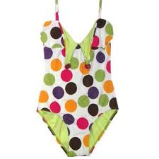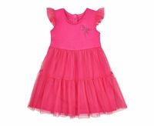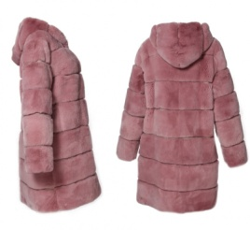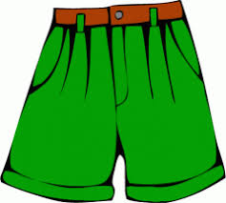
- Only girls wear ________ .
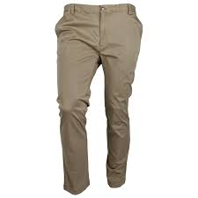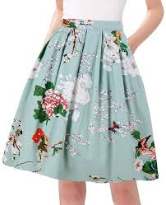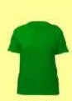
- You put ______ on your feet.
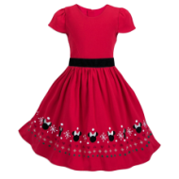
- When it’s warm you wear _______ .
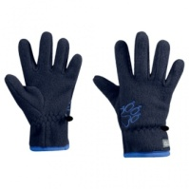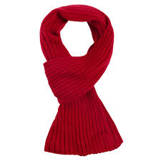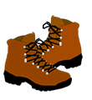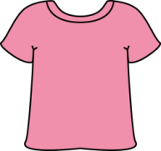

- We usually put on … when we go to bed
. 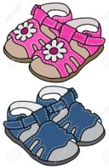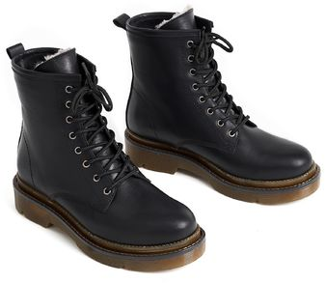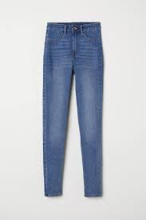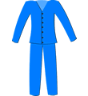

- When it is raining we usually take … .
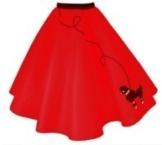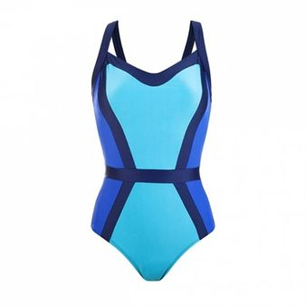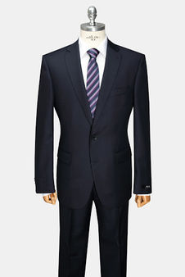
Task 3. Read the text and circle “ true ( + ) ” or “ false ( - ) ”
Today is Saturday. We never go to school on Saturdays. We are at home today, but we can`t go out. The weather is bad. It is rainy and wet. The sky is grey. Tom usually watches cartoons on rainy days. Kate usually reads books. I play computer games.
- Today is Sunday.
- True b) false
- We are at home today.
- True b) false
- The weather is rainy and wet.
- True b) false
- The sky is blue.
- True b) false
- Kate usually watches cartoons on rainy days.
- True b) false
- I usually plays computer games.
- True b) false
Task 4. Read and choose “ was ” or “ were ”
1. She ___ on the island yesterday.
а) was б) were
2. We ___ at the Zoo yesterday.
а) was б) were
3. Mum and Dad ___ in the mountains.
а) was б) were
4. I ___ in the pizza cafe.
а) was б) were
5. It ___ cold yesterday.
а) was б) were
6. Sally ___ in the river.
а) was б) were

